 | 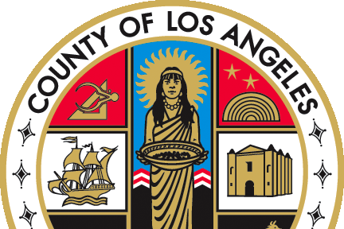   | County of Los Angeles  DEPARTMENT OF CHILDREN AND FAMILY SERVICES  510 S. Vermont Avenue, Los Angeles, California 90020  Board of Supervisors  HILDA L. SOLIS  First District  Holly J. Mitchell  Second District  LINDSEY P. HORVATH  Third District  JANICE HAHN  Fourth District  KATHRYN BARGER  Fifth District  (213) 351-5602
BRANDON T. NICHOLS
Director


Date

TO:
CDSS Adoption Consultant

FROM: JOSEPH PRUSAK
ASSISTANT DIVISION CHIEF

NOTIFICATION REINSTATEMENT OF PARENTAL RIGHTS FOR CHILD (child's legal name and any AKAs) DOB: STATE CASE NUMBER: LACO (number from 4333 Acknowledgement) ADA

Please be advised that parental rights for (name of parent who's parental rights were reinstated), (mother or father) of (date) were reinstated by the Superior Court of California of Los Angeles Juvenile Court on (date) pursuant to WIC 366.26(i)(2). Copies of the minute order reinstating parental rights as well as a copy of the Acknowledgement of the freeing action for this child previously issued by CDSS on (date) are attached for your reference.

This letter is being sent to notify you of this reinstatement action in the absence of a formal CDSS notification procedure.

Please contact (ARA's name), Assistant Regional Administrator, if you require any additional information. (ARA's name)can be reached by phone at (ARA's phone number) or by e-mail at (ARA's e-mail address)

Attachments

BT:(CSW's initials in lower case)

c: (ARA's name)

